Teacher Fellowship programme:
The People of 1381

In partnership with
The People of 1381 project
Funded by

What happened and how do we know?

Genella Thomas
The People of 1381: what happened and how do we know?
Two Year 7/8 lesson plans, possible adaptions and ideas for further activities
This resource is designed to fit over two lessons. It has two key aims: for students to understand what happened in 1381 and to consider how historians work. If you have taught this topic before, it is likely that you have come across the traditional interpretation: the peasants revolted, mainly due to the poll tax, they were led by Wat Tyler and they were unsuccessful. Recent research, including the work of the People of 1381 project, suggests a much more complex picture. The rebels were more organised and diverse, the rebellion was more widespread across England and in many places the grievances of the rebels included local issues.
The first lesson is about discovering what happened in 1381 and is evidence-based. The second lesson is about understanding the work of historians, and in particular thinking about how the work of recent historians has changed our understanding of the events of 1381. It aims for students to get an idea of how painstaking and laborious the process of historical research can be.
In many schools, medieval England is studied chronologically, and in that case, this will follow on from work on medieval society. Students may also make links back to Becket if that has been studied (there are some parallels with the murder of Sudbury). The war with France provides an important context to the events of 1381. The lessons do work as a stand-alone activity, but may require a bit more input about serfdom, villeins, the feudal system and the structure of medieval society.
It provides a useful starting point for thinking about protest and rebellion – many colleagues will cover several protests as part of their Key Stage 3 curriculum. The optional protest grid at the end of Lesson 2 may be useful to revisit when studying other protests.
Each lesson is designed around the same broad structure:
0–20 minutes: introductory activities
20–45 minutes: group or paired task
45–60 minutes: plenary and review activities
There are optional activities so that it can be adapted to suit the needs of students and the time available.
The table that follows gives more detailed information about the lessons. It is structured by: slide number in the lesson PowerPoint; the activity; any additional information that may be helpful (this is also included within the notes section of each slide); suggestions for adaptions; and details of separate resources referred to.
Within the PowerPoints, the notes section will contain references for source material, definitions for key words and a brief description of the activity. Yellow icons denote the activity type and blue icons give the source number. There is also a separate teacher guide for the sources, giving more context for each one (this information is also included on the notes section of the slides).
Resources:
LESSON | RESOURCE | DOCUMENT TYPE | COPYING
1 | L1 PowerPoint | PPT | N/A
 | Evidence pack | PDF | Individual/paired/group (can be printed 2 pages per sheet)
 | Evidence pack – teacher guide | PPT | N/A
 | Evidence worksheet | Word | Individual copy
2 | L2 PowerPoint | PPT | N/A
 | Chronology recap | PDF (editable cards version in Word) | Individual/paired/group
 | People occupations | Word | Individual/paired/group
 | Key figures | Word | Individual/paired/group
 | Evidence review | PDF | Optional
 | Protest grid | Word | Optional

LESSON 1
SLIDE | ACTIVITY | ADDITIONAL INFORMATION | ADAPTIONS | RESOURCE
2 | What is happening and why? | It is a violent image. If this is not suitable for your group, you could substitute Source B instead.  The Tower of London is shown in the background.  It has been selected to get students thinking about the seriousness of events in 1381. It is also potentially a bit of a red herring – students may think back to Becket (if you have covered that). | Can be displayed on the board/projector or a copy given to students. | Evidence pack
3 | Questions to prompt student thinking
4 | Context to the image | Simon Sudbury was also Archbishop of Canterbury. In the medieval period, the role of Lord Chancellor was held by a church person. By the fourteenth century, the Lord Chancellor was the most senior judge after the King, and coordinator of the King’s correspondence. It was therefore a very important court-based, political role.
5 | Brainstorm
6 | Evidence worksheet | This is designed to be a working document, so students don’t need to worry about crossing things out, etc.  NB: Sources and interpretations are used as evidence. | This can be printed on A4 or A3 to meet the needs of your group. Students can work individually, in pairs or in groups. | Evidence worksheet
7 and 8 | Blank copy and worked example of how to record evidence | This activity does not include analysis about the reliability of sources and interpretations as evidence. This is covered in the optional ‘chronicles’ section of Lesson 2.
9 | Introduction of main activity
10 | Introduction of next task
11 | Source analysis  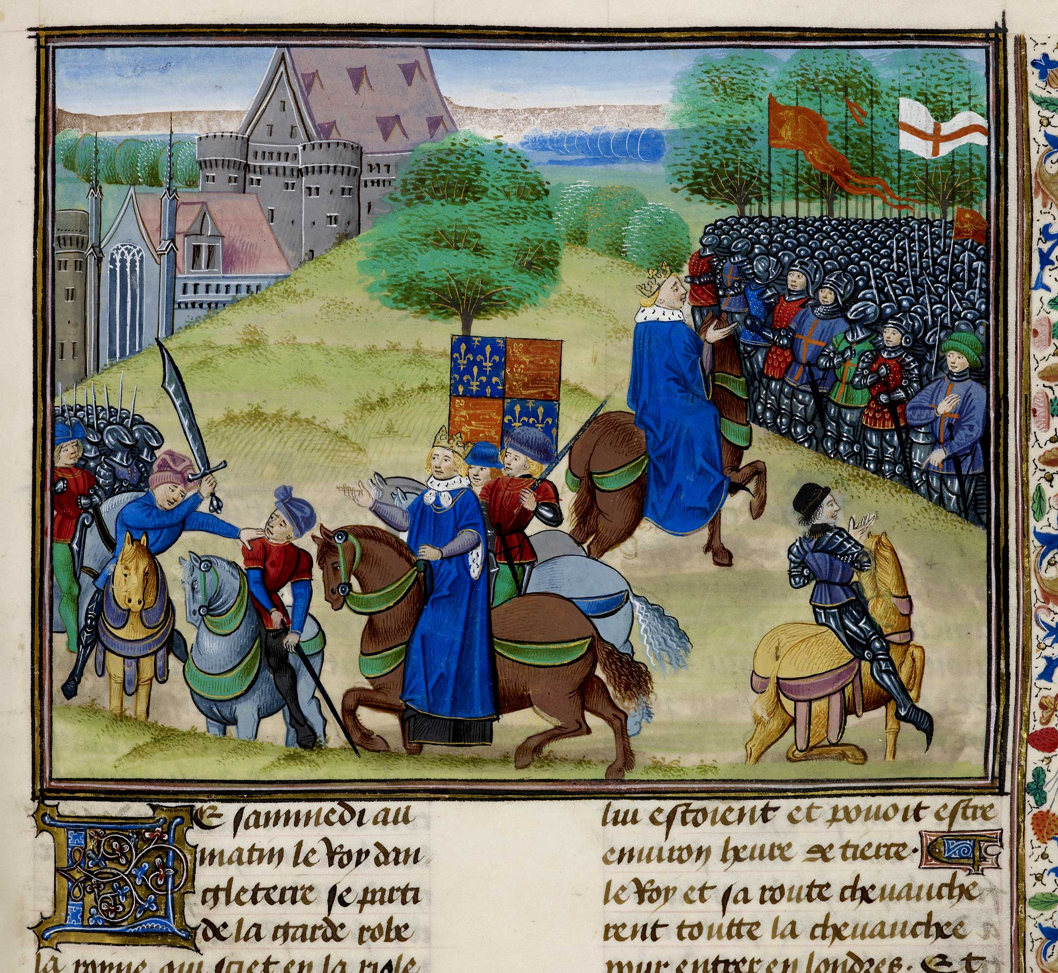  What can students work out? Add to sheet. |  |  | Evidence pack
12 | Qs to support analysis of source |  | There is a useful interactive version of this task on BBC Bitesize linked in the PowerPoint notes.
13 and 14 | Context for both halves of the picture
15 | Focus on the worksheet
16 | Settling students to the main task after modelling – source analysis | The sources and interpretations are included at the end of the PowerPoint (hidden slides), should you wish to go through any as a whole class. There is a separate document, ‘Evidence pack teacher guide’, which gives contexts – this information is also included in the notes section of each slide here as well. The sources and interpretations are very broadly arranged in terms of challenge. | Pairs, groups or whole class.  You can limit the number of sources and interpretations for students to look at. Students can have the whole pack or be given one item to use as evidence at a time. | Evidence pack
17 | Remainder of worksheet
18 | Hidden slide | Worked example included for reference |  | Evidence worksheet
19 | Review | It is likely that students will have gaps and questions about events – these will provide a focus for the next lesson.
20 | Introduce the name of the event | Here, we are really aiming for students to think about how events can be interpreted differently over time: many historians today, for example, would not think that ‘Peasants’ Revolt’ is an accurate name to describe the events of 1381.
21 | Students can add more information to their worksheet | This short animation gives a useful overview and will help students to see the bigger picture of 1381. |  | BBC Bitesize video (link in PowerPoint notes)
22 | Review Source A. Students are now encouraged to use their learning from the lesson to be able to explain the context of Source A from the start of the lesson. | Simon Sudbury was singled out because of his role of Lord Chancellor, and thus being associated with the unpopular poll taxes.
23 | Plenary: students should sum up what they have learnt about 1381. | You may want to discuss more about how and why interpretations change over time.
24 | Traditional interpretation – summary
26–41 | Hidden slides | Evidence – included here for reference and in case you wish to share any with the whole class. |  | Evidence pack

LESSON 2
SLIDE | ACTIVITY | ADDITIONAL INFORMATION | ADAPTIONS | RESOURCE
1 and 2 | Introduction
3 | Recap – put events into chronological order | The correct order is on slide 4 (hidden slide). | Can be one on one page or made into cards.  You may wish to give a completed chronology sheet out to support students during this lesson. | Chronology recap
5–7 | Introduction | You may want to have an initial discussion about what ideas students already have about how historians work.
8 | Common Pleas | Common Pleas rolls are included to give a sense of scale. Each page has lots of information on it, and students can see how many pages are included.
9 | Archives | This encourages students to think about how documents are stored and used.
10 | Video | This video shows some of the People of 1381 team visiting the Essex Records Office. Students can watch the first couple of minutes – it may be easier to mute the video so that you can point things out. In particular, you may want to note how documents are stored (boxes, rolled cupboards, classifications). Again, maybe encourage students to think about the scale of historical research: how many documents are in this archive? How many archives are there in the country? |  | YouTube video – link in PowerPoint and here: www.youtube.com/watch?v=F9a65eu89Qo
11 | Source analysis | Students will look at the various stages of source analysis, starting with the original image, |  | You can print off the source on the PPT for students
12–17 | Source analysis | These slides include various prompted stages of analysis. Key points in the source are indicated. Ask students to think about how long this process might take. How many documents might an historian use in their research?
19 | Main task: additional research (add to evidence worksheet from last lesson).  Best options for whole-class work (with opportunity for paired discussions): Database and Chronicles.  Best options for paired or group work: Occupations, Map | It would be useful to look through the activities beforehand and decide which are most suited to your class. There is more here than can be achieved in one lesson, and so you can choose from this range to create a bespoke lesson that gives students an experience of working with source material as an historian. You will want to make your selections considering the final lesson activity.  Some tasks will require internet access. For reference, the tasks are listed here, broadly in terms of challenge, with the easiest first.  Key figures  Map  Occupations  Chronicles  Database  Additional source: John Shirley  Additional source: Pleas | There are eight possible activities in this section, allowing for small-group work – each group can work on a different task and then feed back. Alternatively, tasks can be selected and done as a whole class or pairs.
20 | Hidden – the link to the database |  |  | https://data.1381.online
21–26 | Database | This is best done as a whole-class activity, followed by individual/paired work to explore the database further. It would be useful to familiarise yourself with the database first of all. The slides give a worked example. | It would be helpful to give students some suggestions of people or places to look for. | Via People of 1381 website: www.1381.online
28 | Occupations | NB: Some occupations we may not be able to work out! Some may also have been spelt incorrectly or differently at the time.  This task aims to get students to think about the type of people involved – it wasn’t just peasants. | It may help to have internet access so that students can look up different occupations. However, the Word document will do if no internet access is possible. | 1381 People: Occupations
30 and 31 | Key figures | This provides simple factual information, and may be most suited to students who are finding the narrative of events challenging. |  | Key figures
32 and 33 | Map of events | This task is to help students see the geographical range of events – and the fact that it was not just London and the South East. Similarly, encourage students to look at the dates to note how events did not end after Wat Tyler was killed in London. |  | https://padlet.com/ha1381/1381-revolt-map-bnofracmmfti1cyc
34–36 | Additional source: John Peper (pleas) | Key points are highlighted. This suggests the local nature of the Revolt and an opportunity to settle scores – they are stealing property from one person. | Can print either version for students (with or without highlighting). | Can print slides for students.
37–39 | Additional source: John Shirley | This suggests how worried the authorities were in the aftermath of the events in London. John Shirley was arrested and executed for talking in a tavern, and did not even have a full trial. It also shows how rebels were moving around the country. | Can print either version for students (with or without highlighting). | Can print slides for students.
40–46 | Chronicles | This provides information relating to the chronicles generally, and then the four main chronicles about the event, plus questions to think about. |  | Print slides 42–45 for students
47 | Review
48 | Recent interpretations | It is worth noting that some of the new research is possible because of technology – we can now use databases, so we can easily cross-reference a huge amount of data.
49 and 50 | Review sheet | Students should now reflect on what they have found out in this lesson.  This activity is to help them to realise that history is not always clear-cut, and that historians don’t always have all the evidence that they need. |  | Evidence review
51 | Plenary | The slide has three possible plenary questions.  If students are thinking about why it is hard to find out about 1381, they may want to consider:  - How do we find the voices of the past? Literacy, survival of materials, etc.  - ‘Fake news’ today and the media – do we trust them?  - How much was suppressed at the time?  - How much evidence has just been lost over time?
52 | Optional plenary: Is the term ‘Peasant’s Revolt’ accurate? | This grid is useful for thinking about the scale of the Revolt, as well as thinking about the context of it compared to other protests. |  | Protest grid

